May half term 2026
(Monday 25th- Friday 29th May 2026)
What’s on in Chelmsford?
A guide to some free/ low-cost activities
Essex ActivAte   | Throughout the school holidays  FREE half term clubs for eligible school aged children- Holiday, Activity and Food.  All attendees receive free lunch |   www.activeessex.org/children-young-people/essex-activate/
Chelmsford Cathedral  Chelmsford Cathedral  New Street, Chelmsford, Essex CM1 1TY | Trails of discovery tour - All week  If you're visiting the Cathedral with children, make sure you pick up one of our free Trails of Discovery worksheets created in collaboration with The Arts Society.  The trails are designed to help visitors explore the art, architecture and history of the Cathedral. We're delighted to have two sets of trails; a trail for preschoolers and one for primary aged children.  You can pick up a trail at the desk outside St Peter's Chapel. |   www.chelmsfordcathedral.org.uk/whats-on/children-and-family-ministry
Essex Police museum  Essex Police Museum Essex Police Headquarters, Springfield, Chelmsford CM2 6DN  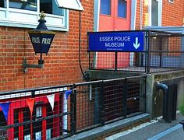 | Open Wednesdays in school holidays  And every Saturday  Open 10am-4pm  FREE admission  NO car park  Lots of free activities and interactive exhibits for children of all ages |   https://www.essex.police.uk/museum
Essex Child and Family Wellbeing Service  Support for families with children aged 0-19  All activities listed here are FREE, no booking is needed- just pop along. Parents/ carers to stay for the sessions. | Weds 27th May 2026  1pm-2.30pm Baby Beginnings Group for 0-12 month olds  FREE admission and NO booking needed  Sensory Play, baby toys, stories, songs and more  1pm-2.30pm Little Explorers Group for 9-18 month olds  FREE admission and NO booking needed  Sensory Play, toys, soft play, stories, songs and more  1pm-2.30pm: Infant Feeding Support  Drop in for support with all things feeding- whether breastfeeding, formula feeding, combi or more- we can support  All @ Chelmsford West Family Hub, Dixon Ave, CM1 2AQ  Friday 29th May 2026  10am-11.30am  Stay, Play and Learn group for 1-8 year olds  @ Chelmsford West Family Hub, Dixon Ave, CM1 2AQ  FREE admission and NO booking needed  Fun activities, crafts, outdoor play, singing and more! |   https://essexfamilywellbeing.co.uk/hubs/chelmsford-central-family-hub/
Messy Church  Christ Church Chelmsford  164 New London Rd, Chelmsford CM2 0AW ·  FREE event open to all | 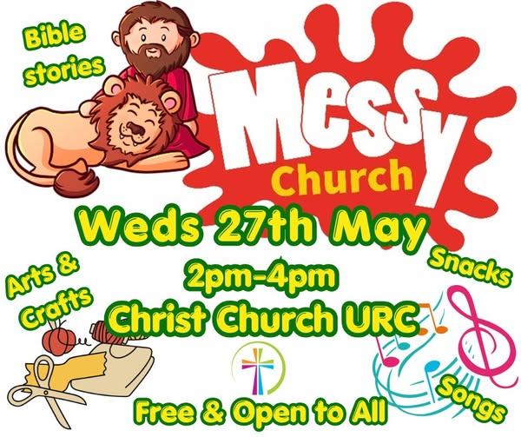 | www.facebook.com/ChristChurchChelmsford
Museum of Chelmsford  Oaklands Park, Moulsham Street, CM2 9AQ  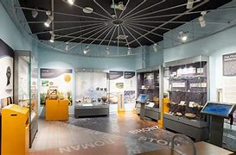 | Open Daily  10am-4pm  Children under 16- FREE  (£4 per adult)  2x free playgrounds in grounds of Oaklands Park |   www.chelmsford.gov.uk/museums/visit/chelmsford-museum/
Chelmsford Community Church- Spring Family Crafts |  | https://fb.me/e/3O7T0IHfM
Free story-telling event  Thursday 28th May 2026  11am-12pm  Twitten Green- Galleywood | 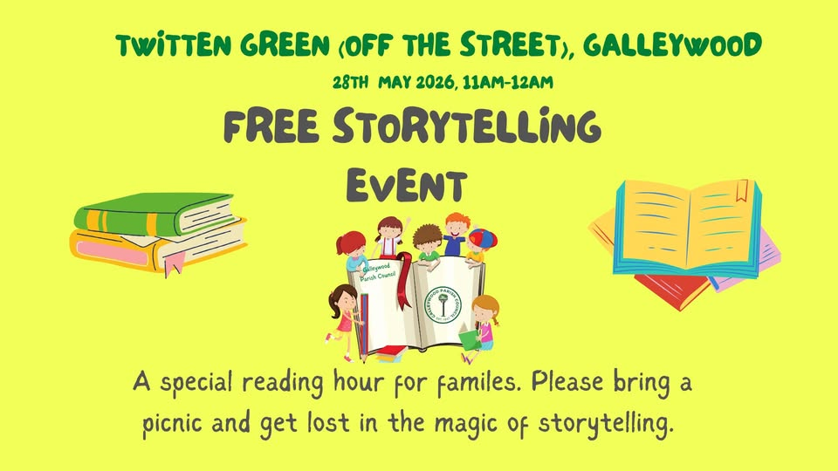 | Run by Galleywood Parish Council  https://fb.me/e/7RnTmNIXY
Chelmsford Junior Parkrun  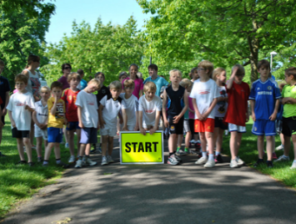 | 9am every Sunday  Chelmsford junior parkrun provides free, weekly, timed, 2k events for young people aged between 4 – 14.  parkrun isn't a race, it’s a fun activity where participants can walk, jog, or run, with every finish celebrated equally.  There's no need to book. There’s a First Timers briefing at 08:50 with the event starting at 09:00.  For more details visit our website at www.parkrun.org.uk/chelmsford-juniors or see our Facebook page and the one time, free registration is at www.parkrun.org.uk/register. | www.parkrun.org.uk/chelmsford-juniors  www.parkrun.org.uk/register
Playgrounds  Lots of play areas for children to use  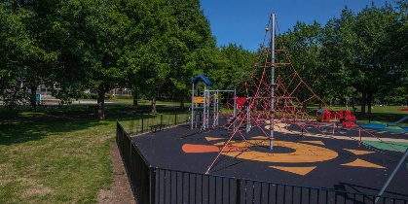 | Locations across Chelmsford |   https://loveyourchelmsford.co.uk/green-spaces/play-areas/
Walking and cycling routes in Chelmsford   | Wide range of walking and cycling routes across Chelmsford to try out with your family over the school holidays |   www.chelmsfordforyou.co.uk/walking-cycling-routes
Essex Library Service –  Borrow books. Wide range of Free activities for children. Free use of computers.  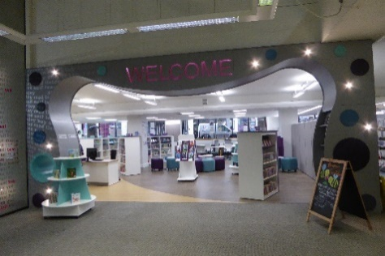 | There are 9 libraries in the Chelmsford District that you can access for FREE.  Please click on their event finder for their full listing of events.  Some free events to highlight for this half term below  Chelmsford Library –  - Every Saturday 10am-1030am  Dads and Doughnuts- rhyme time and doughnuts!  - Saturday 23rd May 2026 11am-3pm  Pokemon trail event  - All week  Rhyme time sessions running as usual- bookable online  Galleywood Library-  - Tuesday 16th May 2026 3pm-4pm  Dog Man Doodles  Come and join us for an afternoon of incredible Dog Man activities including drawing Dog Man characters and creating your own comic strip.  Broomfield Library-  - Weds 27th May 10am  Baby and Toddler Rhymetime  Great Baddow Library  - Wednesday 27th May 2026 10am-11am  Rhyme Time  North Melbourne Library  - Saturday 23rd May 2026 11am-11.30am  Family Story and craft time  - Friday 29th May 2026 10.15-10.45  Rhyme Time  Writtle Library  - Saturday 23rd May and Weds 27th May 2026 10.30am-11am  Rhyme Time  - Tuesday 26th May 2026 9.30am-12pm  Children’s crafts |   https://libraries.essex.gov.uk/events/location/chelmsford
Table Tennis and Table football  Beaulieu Community Centre  £5 per 45 minute session – for upto 8 children (price per 45 min time slot NOT per child)  Tues-Fri of May half term |  | https://beaulieucommunitycentre.co.uk/our-events/

